Total Volume by Ticker - 2016

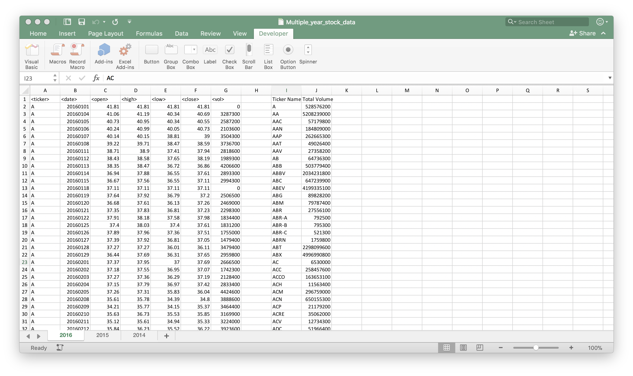

Total Volume by Ticker – 2015

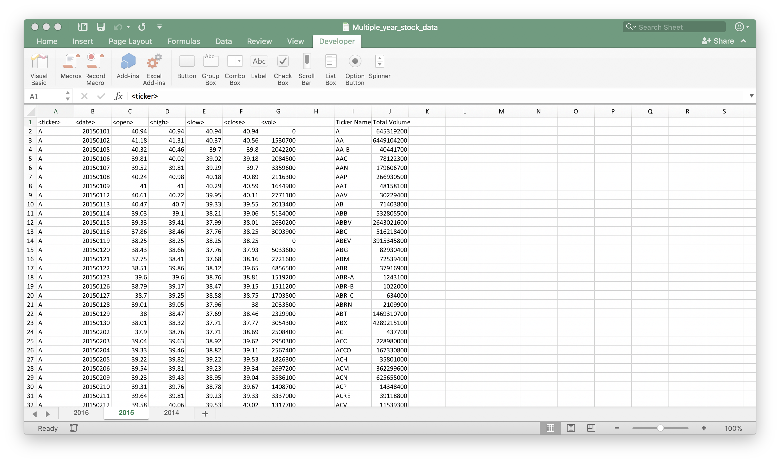

Total Volume by Ticker – 2014

